**ROLE: SCRUM MASTER**

**ARTEFACT 1- MINUTES OF MEETINGS**

I have included three examples of the minutes of meetings that I took after each meeting and tutorial. I took these minutes to ensure that the team was keeping on task and so that each week we could look back on what we had discussed last week and whether we had improved since then. I also found it useful to keep track of who had been attending each meeting.

Inner City Hackers

Weekly Meeting

Place: QUT Gardens Point

Date: 7 August 2017

Time: 12.00pm – 1:30pm

Present: Rachel, Victoria, Ian, Matthew

**Apologies:**     N/A

**BUSINESS**

1. User stories
   1. We discussed the user stories that we had generated so far and made some small amendments.
   2. We added additional user stories.
   3. We applied the MoSCoW method to the stories to determine which were most important.
   4. We created a technology grid for the Must Have user stories.
   5. We assigned values using the Poker method
2. Client team
   1. Provided feedback on the current user stories
   2. Created a list of user stories that needed to be amended.
3. Developer Team
   1. Explained the process behind implementing the user stories
   2. Discussed backlog of stories
   3. Started to develop acceptance criteria
4. Estimates
   1. Estimates of the user stories were created
   2. These will be reviewed at our next meeting.

Inner City Hackers

Weekly Meeting

Place: QUT Gardens Point

Date: 14 August 2017

Time: 12.00pm – 1:30pm

Present: Rachel, Ian,

**Apologies:**     Matthew, Victoria,

**BUSINESS**

1. Software Architecture Pattern
   1. We discussed what software architecture pattern would be suitable for the Smart City development project
   2. As a group we drew logical and physical designs of the architecture pattern.
   3. We explained the reasons why we chose this software architecture pattern and will provide this documentation to Matthew and Victoria and wait to hear back from them whether they agree with the decisions and diagrams drawn.
2. Client team
   1. Provided feedback on working user stories
   2. Client team provided informal feedback on user stories
3. Development Team
   1. Showed sprint plan with actual times recorded for tasks.
   2. Demonstrated burndown chart.
   3. Group discussed that the burndown chart needed to speed up a bit to be in accordance with the predicted time. Development team acknowledged this.
   4. Ian to touch base with Matthew to confirm what user stories he had competed so that the burndown chart could be accurately updated.

Inner City Hackers

Weekly Meeting

Place: QUT Gardens Point

Date: 29 August 2017

Time: 12.00pm – 1:30pm

Present: Rachel, Ian,  Matthew, Victoria,

**Apologies:**

**BUSINESS**

1. User Interfaces
   1. Client team sketched draft user interfaces for development team.
   2. Client team to transform sketches onto computer using proto.io
   3. Client team discussed client side validations required for each screen.
2. Client team
   1. Provided feedback on working user stories
   2. Client team provided informal feedback on user stories
3. Development Team
   1. Showed sprint plan with actual times recorded for tasks.
   2. Demonstrated burndown chart.
   3. Development team discussed user interfaces, design techniques, client side validation techniques.

**ARTEFACT 2 – USER STORIES**

The following test cases were written by the Scrum Master (myself) and the client team (Victoria). We wrote them in a way that we thought would be most convenient for the development team to understand and then to allow us to test the user stories. Although my role is SCRUM master, I have been actively engaged in client side work so that I am actively participating in the group project.

|  |  |  |  |  |  |  |
| --- | --- | --- | --- | --- | --- | --- |
| **Test Case ID #** | **Title** |  | **Story** | **Description** | **Test Step** | **Expected Result** |
| **TC01** | Student search for libraries |  | As a Student, I want to be able to search for libraries near me so that I can find places to study and research more easily | A registered student should be able to search for the libraries near them. Precondition: the user must be registered to the system with a username, password and user type. The user needs to be correctly logged in | 1. Student logs in. 2. Search displays available libraries in a list. 3. Check to confirm all test libraries are displayed. | The libraries that are in the specified area are listed |
| **TC02** | Student search for colleges |  | As a Student, I want to be able to search for colleges near me so I can make an informed choice of where to go and study. | A registered student should be able to search for colleges near them Precondition: the user must be registered to the system with a username, password and user type. The user needs to be correctly logged in | 1. Student logs in. 2. Search displays available colleges in a list. 3. Check to confirm all test colleges are displayed. | The colleges that are in the specified area are listed |
| **TC03** | Tourits search for hotels |  | As a Tourist, I want to be able to search for hotels so that I can easily choose which hotel I want to stay at. | A registered user should be able to search for hotels near them Precondition: the user must be registered to the system with a username, password and user type. The user needs to be correctly logged in | 1. Tourist logs in. 2. Search displays available hotels in a list. 3. Check to confirm all test hotels are displayed. | The hotels that are in the specified area are listed |
| **TC04** | Tourits search for City Infomation |  | As a Tourist, I want to be able to search city information so that I can plan my holiday sightseeing and decide where to visit. | A registered tourist should be abele to search for city infomation near them Precondition: the user must be registered to the system with a username, password and user type. The user needs to be correctly logged in | 1. Tourist logs in. 2. Search displays available city information in a list. 3. Check to confirm all test city information is displayed. | The city information that is relevant to that specified area is displayed |
| **TC05** | Businessman search for industries |  | As a Businessman I want to be able to search industries so that I can plan work related scenarios. | A registered Businessman should be able to search industries near them Precondition: the user must be registered to the system with a username, password and user type. The user needs to be correctly logged in | 1. Businessman logs in. 2. Search displays available industries in a list. 3. Check to confirm all test industries are displayed. | The relevant industies are displayed |
| **TC06** | Businessman search for cities |  | As Businessman I want to be able to search city information so that I can plan my sightseeing and decide where to visit. | A registered Businessman should be able to search for City Infomrayion. Precondition: the user must be registered to the system with a username, password and user type. The user needs to be correctly logged in | 1. Businessman logs in. 2. Search displays available city information in a list. 3. Check to confirm all test city information is displayed. | The city information that is relevant to that specified area is displayed |
| **TC07** | Businessman search for hotels |  | As a Businessman I want to be able to search hotels so that I can easily choose which hotel I want to stay at. | A registered Businessman should be able to search for hotels near them. Precondition: the user must be registered to the system with a username, password and user type. The user needs to be correctly logged in | 1. Businessman logs in. 2. Search displays available hotels in a list. 3. Check to confirm all test hotels are displayed. | The hotels that are in the specified area are listed |
| **TC08** | Administrative User create new account |  | As an Administrative User I want to be able to to create accounts for new administrators to that I can add more Administrative help as the system expands. | An Administrative User should be able to create new Administrative Accounts Precondition: the user is an already registered Administrator and is correctly logged into the system. | 1. Admin logs in. 2. Admin can click find a user 3. Admin can give that user administrative access |  |
| **TC09** | Administrative User upload map |  | As an Administrative User I want to be able to upload a map of the city to improve the visual representation of the software | An Administrative user should be able to upload a map Precondition: the user is an already registered Administrator and is correctly logged into the system. | 1. User clicks on a city. 2. User clicks edit. 3. User clicks upload map. 4. User clicks confirm |  |
| **TC10** | Administrative User add POI |  | As an Administrative User I want to be able to add New POI's to keep the system updated. | An Administrative User should be able to add new POI's to the system Precondition: the user is an already registered Administrator and is correctly logged into the system. | 1. Admin logs in. 2. Admin goes to portal  3. Admin clicks add new POI |  |

**ARTEFACT3 – USER INTERFACE MOCKUPS**

I have included some examples of the user interface mockups that I completed to assist the client and development team to design the website. We worked as a team to sketch them out on paper and then I made these mockups using proto.io

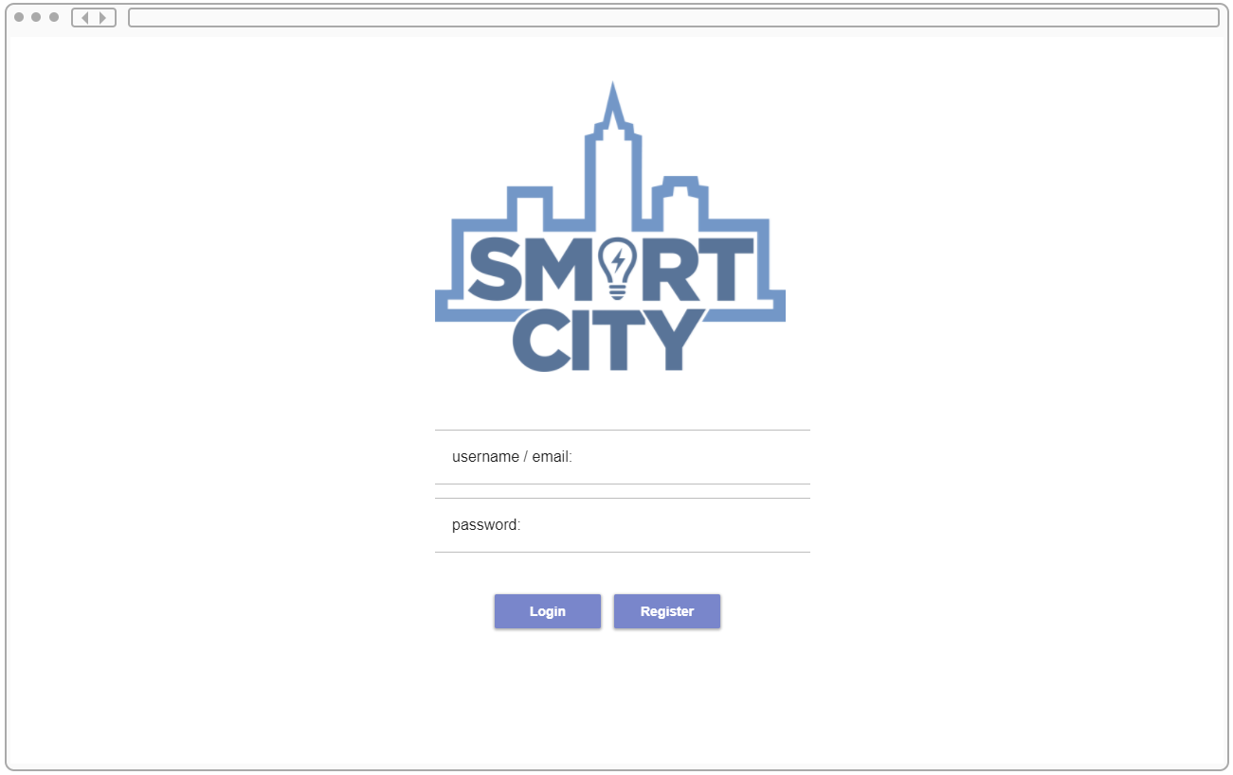

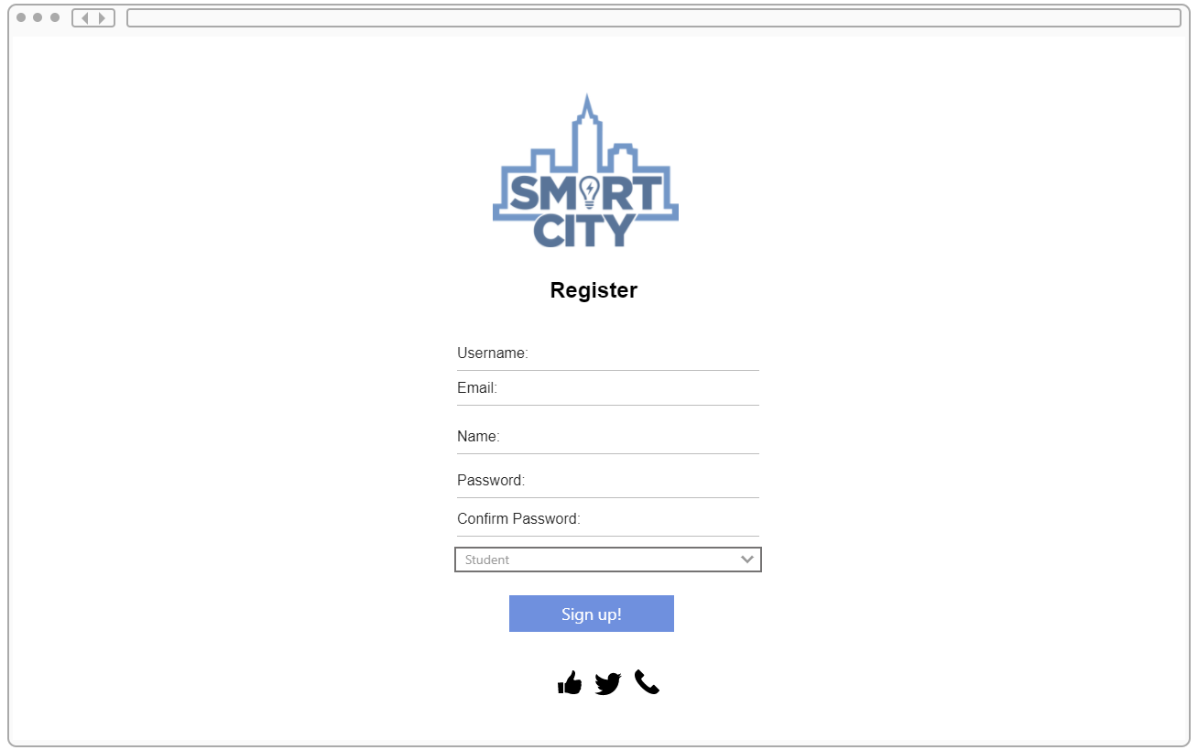

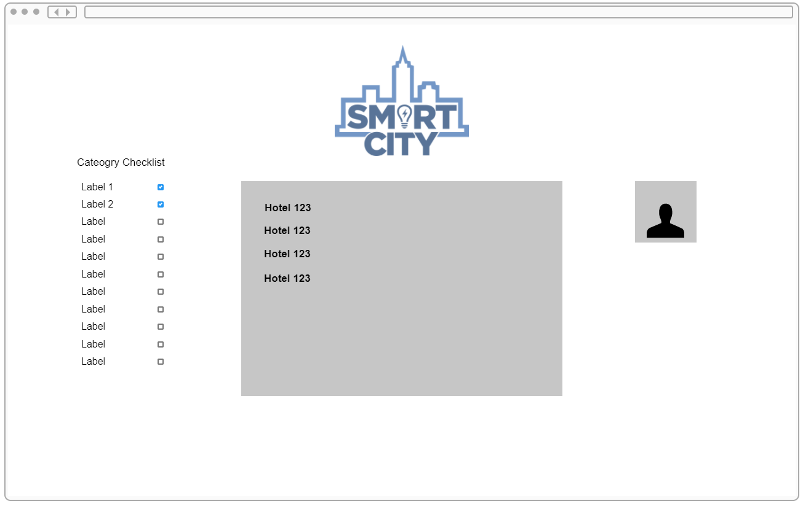

**ARTEFACT 4 – SCREENSHOT CONVERSATIONS – TEAM MANAGEMENT**

I have included an example of my communication as SCRUM master with the team to ensure that the team is happy and working well together. I would check in with each member of the team at least once a week.

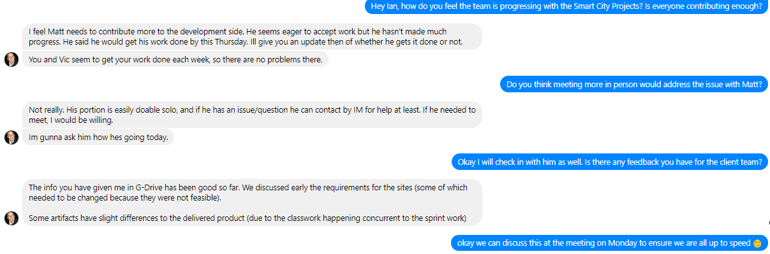

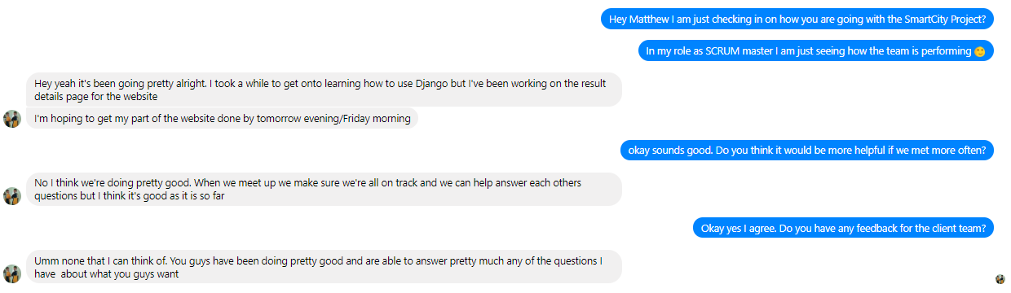

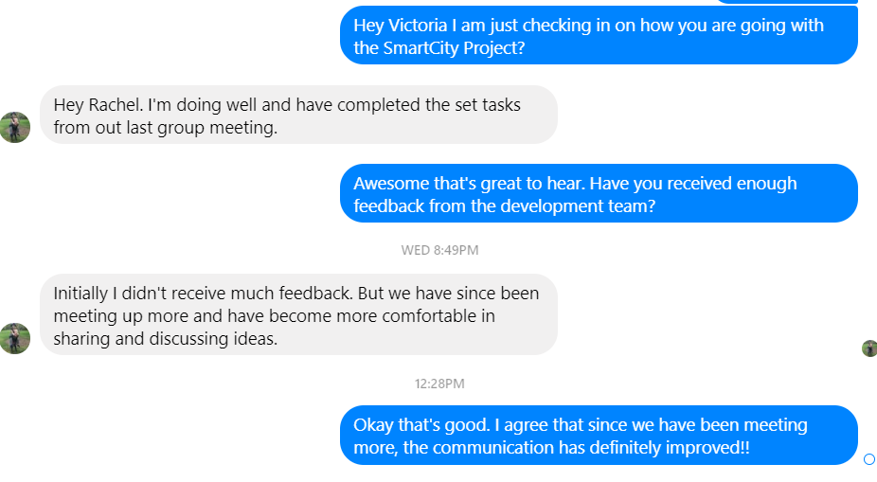

**ARTEFACT 5 – TRELLO BOARD**

I made this Trello board to ensure that the development team is effectively communicating with the client team as to the progress that is being made. Once all the tasks were put in the planned column, the development and client team moved them as they had been completed. I set up sufficient notifications that the team received when certain tasks had been completed.

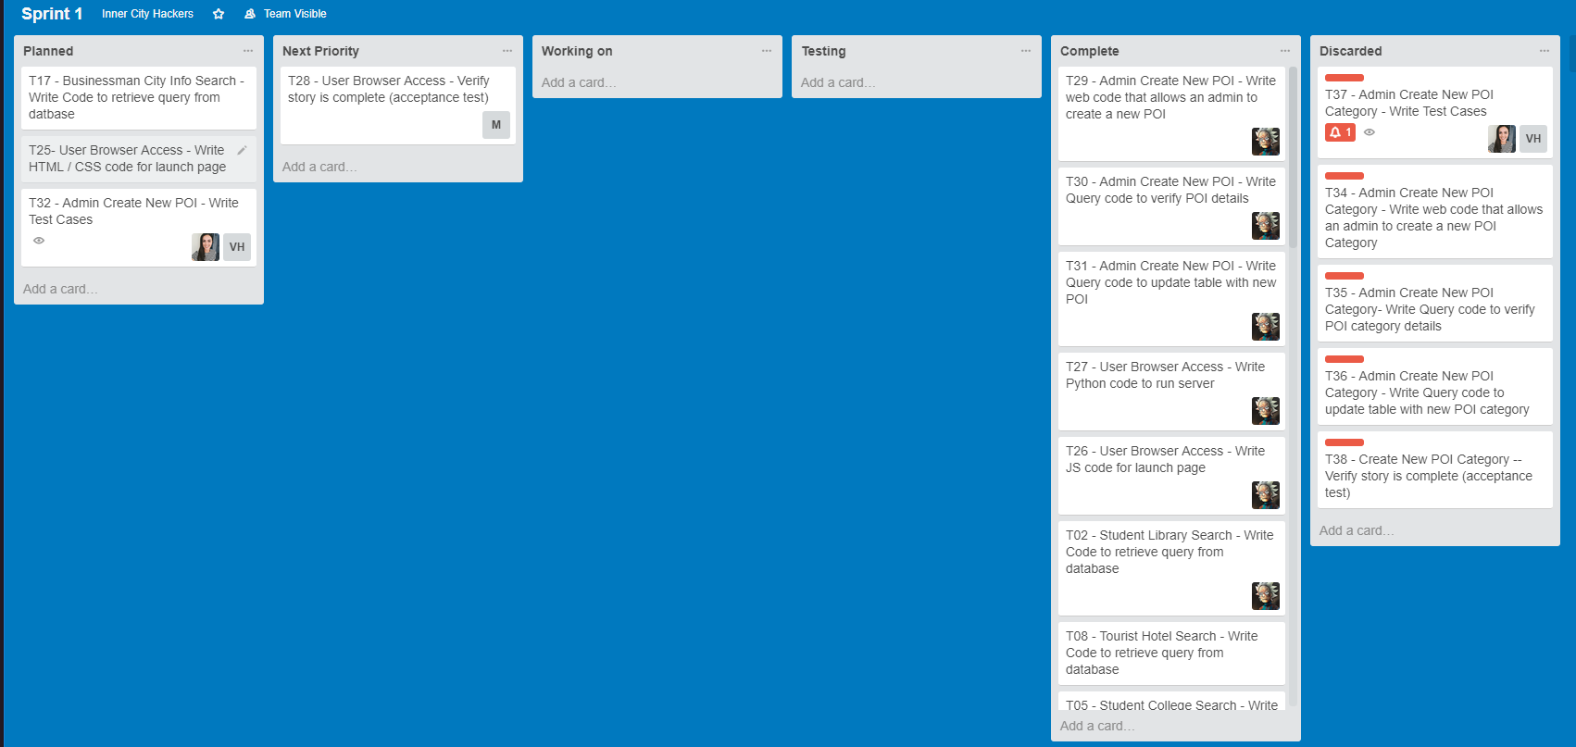

**ARTEFACT 6 – HTML CODE FOR REGISTER PAGE**

My ability to code in CSS is not very well developed which is why I did up the mockups first using proto.io. I completed this HTML code so that I could discuss what client side validation was required with the development team.

